CS 162 Worksheet 1
- C++ data type review: indicate if each the following matched with the correct type:
Constant | Type | Right/Wrong (correction)
4.0 | int
5 | int
‘a’ | string
5. | double
5 | char
“5.0” | char

- Arithmetic Operators
Operator | Name | Example
+
-
*
/
%

- Relational operators: to perform comparison of variables, constants, or expressions in C/C++
Operators(s) | Meaning | Example
==
!=
<
>
<=
>=

- Conditional Statements: if/else
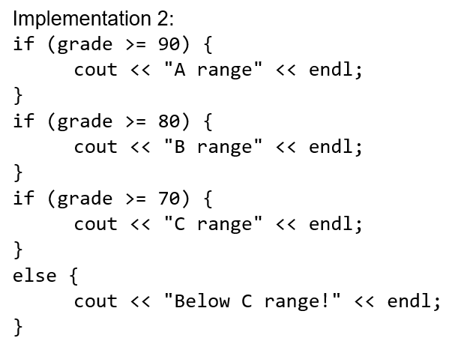
What will each implementation print if ‘grade’ stores 95?
Implementation 1:
if (grade >= 90) {
cout << "A range" << endl;
}
else if (grade >= 80) {
cout << "B range" << endl;
}
else if (grade >= 70) {
cout << "C range" << endl;
}
else {
cout << "Below C range!" << endl;
}

What did you notice about if and else?
if:
else:

- Logical Operators: to create compound conditions
Operators(s) | Meaning | Example
&&
||
!

Quick check: Which of the following is NOT a condition to check if the integer x is in the range [-1 to 5]?
- x >= -1 && x <= 5
- -1 <= x <= 5
- !( x < -1 || x > 5)
- x > -2 && x < 6

- Common mistakes
- Using assignment operator (=) rather than equality check operator (==)
Correct the following code:
int x;
cin >> x;
if (x = 0)
cout << “x is 0” << endl;

Tip: When comparing with a constant, many companies recommend flipping the order to:
if (0 == x) { /*some code*/ }
This way, the code won’t compile if you accidentally write:
if (0 = x) { /*some code*/ }

- Using multiple if statements rather than if … else
Correct the following code:
int x, y;
cin >> x >> y; //takes two inputs, and store them into x and y, respectively
if (x != y)
x = 5;
if (x == y)
y = 7;

- Wrong formulated conditions.
Correct the following code:
if (0 <= x <= 9) { /*some code*/ }

if (x == 0 || 1) { /*some code*/ }

- Loops
- for loop: used when you DO know the number of times to iterate BEFORE the loop starts
Ex: print out all multiples of 7 from 0 to 100, inclusive

- while loop: used when you DON’T know how many times to iterate before the loop starts
Ex: let user guess my secret number until they are correct
int guess;
int secret_num = /* some code */;
cin >> guess;
// complete the rest….

Tip: Use while loop whenever you see/use “until”, until x == while not x
For example: keep guessing until correct == keep guessing while not correct

- do-while loop: often used to run/play again. Loop body is executed at least once
Ex: ask the user whether they want to run the program again, 1-yes, 0-no

- nested loop: The inner loop executes completely for each single iteration of the outer loop
Ex: Trace through the execution of the following code and show what will be printed.

for (int i = 0; i < 2; i++) { i j
for (int j = 0; j < 3; j++) {
cout << i << “ ” << j << endl;
}
}

