CS 162 Worksheet 7
Read and trace the following code, and answer the following questions.
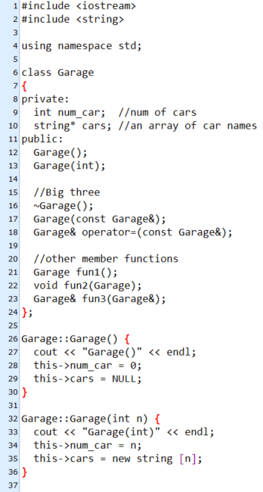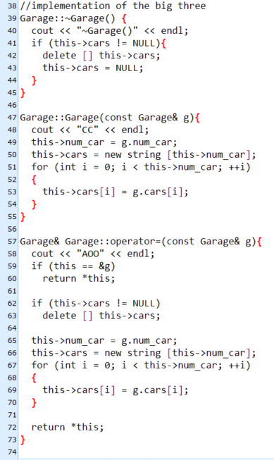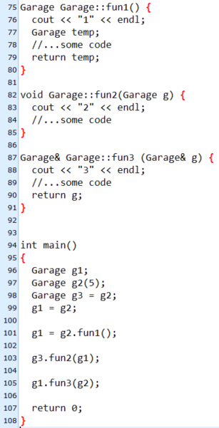

- For line 12 and 13, which one is the default constructor, and which one is the non-default constructor?

- Label the big three from line 16-18. Options: Copy constructor, Assignment Operator Overload, Destructor

- Explain the difference between shallow copy and deep copy.

- Which parts within the big three functions implement the deep copy?

- What is the purpose of line 59-60?

- What is the purpose of line 62-63?

- What is the output of line 96-99?

- What is the output of line 101?

- What is the output of line 103?

- What is the output of line 105?

- What is the output after line 108?

- When would each of the big three functions be called?

- From your answers above, what is the most efficient way to pass an object into a function?
For each memory-related error reported by valgrind below, explain what caused the error and how to fix it:
- __________________________________________________________________________
main.cpp:
________________________________________________________________________
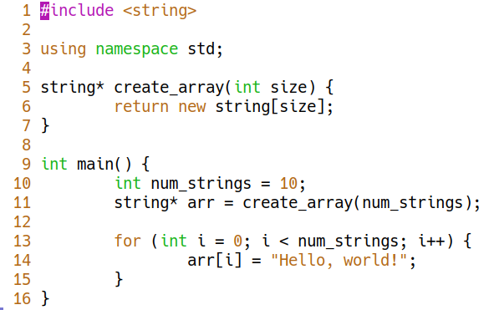
__________________________________________________________________________
Valgrind output:
__________________________________________________________________________
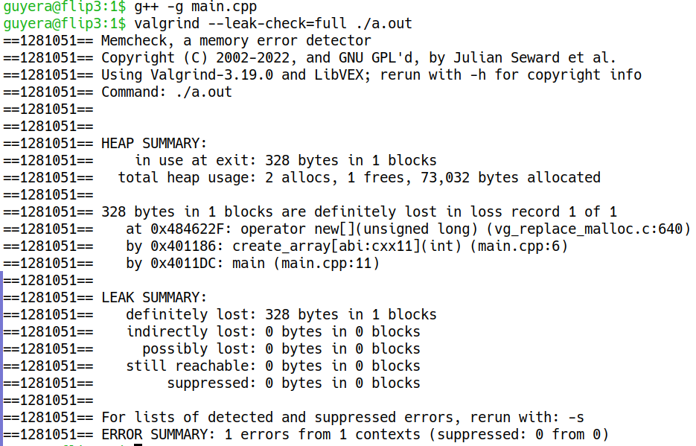
- __________________________________________________________________________
main.cpp:
__________________________________________________________________________
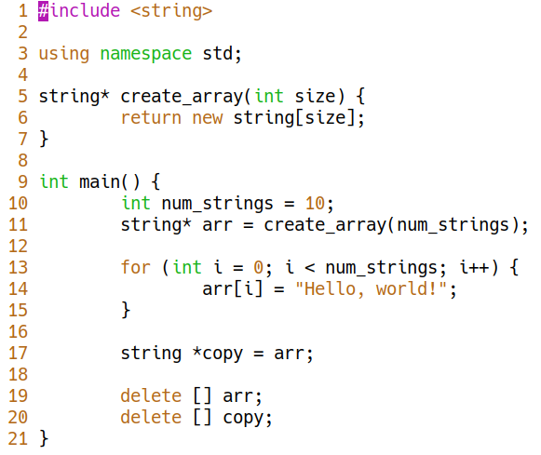
__________________________________________________________________________
Regular output:
__________________________________________________________________________
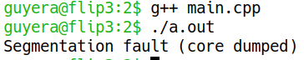

__________________________________________________________________________
Valgrind output (this produces many errors, so here’s just the first error and the heap summary):
__________________________________________________________________________
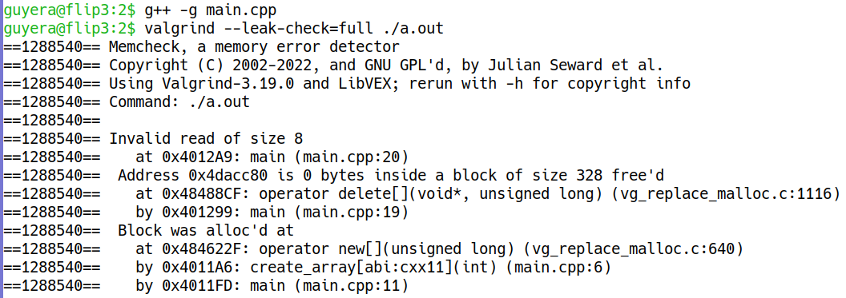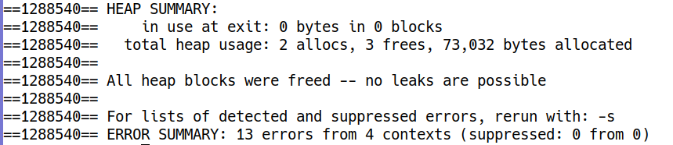
- __________________________________________________________________________
main.cpp:
__________________________________________________________________________
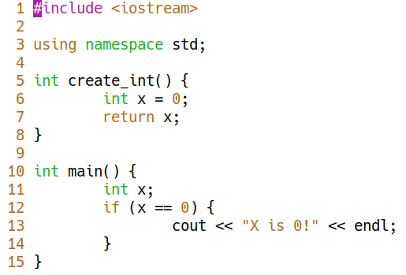
__________________________________________________________________________
Valgrind output:
__________________________________________________________________________
